Analyse
1. Objectives:
- Manage book borrowing and returning processes for library members.
- Automatically update the available book stock count.
- Calculate overdue fines at RM 0.50 perday when a book is kept over 14 days.

2. Key Logic & Rules:
- Borrowing (Type 1): Decrements stock by 1 if available. If stock is 0,
the transaction fails.
- Returning (Type 2): Increments stock by 1 and prompts for total days borrowed.
- Overdue Calculation: Fines apply only if borrowed days exceed 14 days.

3. Assumptions & Constraints:
- Inputs are valid positive numbers.
- Transaction types are strictly restricted to 1 (Borrow) or 2 (Return).

IPO
INPUT:
memberID, bookID, bookQuantity, transactionType, daysBorrowed

PROCESS:
1.Read memberID,bookID,bookQuantity, transactionType
2.IF transactionType == 1 THEN
IF bookQuantity > 0 THEN
bookQuantity = bookQuantity -1
Status= “ Borrowing Successful”
Fine = 0.00
ELSE
Status = “Failed (Book Out of Stock)”
ENDIF
3. ELSE IF transactionType == 2 THEN
Read daysBorrowed
bookQuantity = bookQuantity + 1
IF daysBorrowed > 14 THEN
fine = (daysBorrowed - 14) * 0.50
condition = "OVERDUE"
ELSE
fine = 0.00
condition = "On Time"
ENDIF
Status = "Return Successful"
4.ELSE
Status = “Invalid TransactionType!”
5.ENDIF

OUTPUT:
Status
bookQuantity
fine
condition

PSEUSEDOCODE
START
1. READ memberID, bookID, transactionType
2. READ borrowDate, returnDate, finePerDay
3. READ availableQuantity
4. IF transactionType == "Borrow" THEN
5. IF availableQuantity > 0 THEN
SET availableQuantity = availableQuantity - 1
SET transactionStatus = "Borrow Successful"
ELSE
SET transactionStatus = "Borrow Failed: Book Out of Stock”
6. ELSE IF transactionType == "Return" THEN
SET availableQuantity = availableQuantity + 1
SET allowedDays = 14
SET actualDays = returnDate - borrowDate
7. IF actualDays > allowedDays THEN
SET overdueDays = actualDays - allowedDays
SET overdueFine = overdueDays * finePerDay
ELSE
SET overdueDays = 0
SET overdueFine = 0.00
8. IF
SET transactionStatus = "Return Successful"
ELSE
SET transactionStatus = "Invalid Transaction Type”
9. DISPLAY "Transaction Status: ", transactionStatus
10. DISPLAY "Updated Book Quantity: ", availableQuantity
11. DISPLAY "Overdue Fine: RM", overdueFine
END

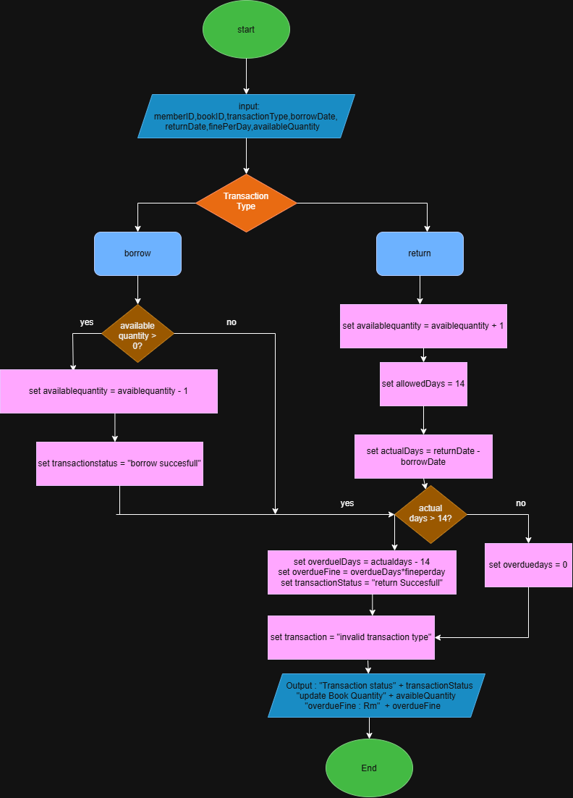

TEST CASE
CASE 1:
Enter Member ID : M001
Enter Book ID : B001
Enter Available Quantity:3

Select Transaction Type (1 =Borrow, 2 =Return): 1
Status : Borrowing Successful
Updated Quantity : 2
Overdue Fine : RM 0.00

CASE 2:
Enter Member ID : M001
Enter Book ID : B001
Enter Available Quantity:3

Select Transaction Type (1 =Borrow, 2 =Return):2
Enter Number of Days Borrowed: 10

Status : Return Successful
Updated Quantity : 4
Return Condition : On Time
Overdue Fine : RM 0.00

CASE 3:
Enter Member ID : M001
Enter Book ID : B001
Enter Available Quantity:4

Select Transaction Type (1 =Borrow, 2 =Return):2
Enter Number of Days Borrowed: 15

Status : Return Successful
Updated Quantity : 5
Return Condition : OVERDUE 8 day
Overdue Fine : RM 0.50

